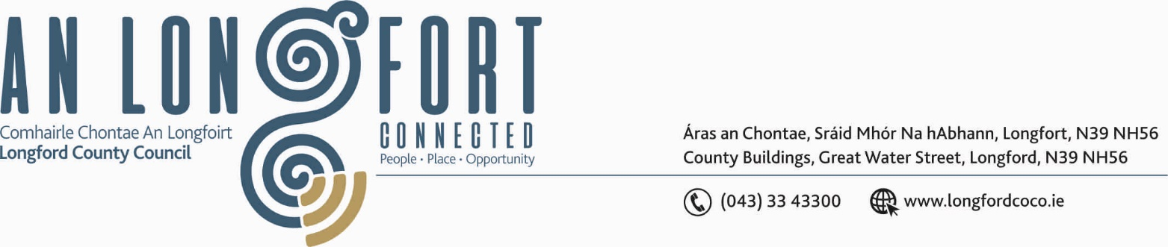

LONGFORD MUNICIPAL DISTRICT

Please note Meeting will be held using Microsoft Teams.

30th March 2020.

To: Each Member of Longford Municipal District.

Dear Member,

You are requested to attend Meeting of Longford Municipal District to be, held using Microsoft Teams, on Friday, 3rd April 2020 at 4.00 p.m. to transact business, as set out on the Agenda hereunder.

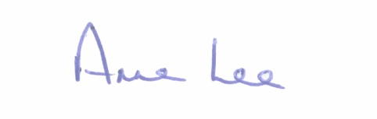
Yours sincerely,

_______________
Anne Lee,
Meetings Administrator.

AGENDA

Prayer before meeting.

- Confirmation of Minutes of the following meetings of Longford Municipal District held on
the 12th February 2020 -
(a) Committee Meeting.
(b) February Municipal District Meeting.

- Matters arising from Minutes.

- Declaration of Interest by Members.

- Consideration of applications for funding under the 2020 Community Grant Support
Scheme.

